Material: 9780192865533

Bp: 100094043

**Consignment Order Types: (**Order🡪Delivery🡪Invoice)

Fill-up: ZKB🡪 13158 🡪 300002493  
Issue: ZKE🡪 13159 🡪 300002494 🡪 500058051  
Returns: ZKR🡪250001071🡪 450000119🡪 700000103  
Pick-up: ZKA🡪250001073 🡪 450000120

**Fill-up:**

* Stock will be reduced from Unrestricted use and will be added in customer consignment
* Involves picking
* It does not have billing

**Issue:**

* Stock will be reduced from Customer consignment and will be added in customer consignment
* It doesn’t involve picking
* It does have billing

**Returns:**

* Order will be created with issue’s invoice as reference(like credit memo).(like credit memo). Stock will be added into Customer consignment.
* It doesn’t involve picking
* It does have credit memo billing

**Pick-up:**

* Stock will be reduced from Customer consignment & added back to our storage location.
* It doesn’t involve picking & invoicing.

1. **Fill-up:**

Sales order type: ZKB  
Item Category🡪 ZKBN  
SLC🡪 E1

MMBE for 9780192865533 against 100094043 is 5

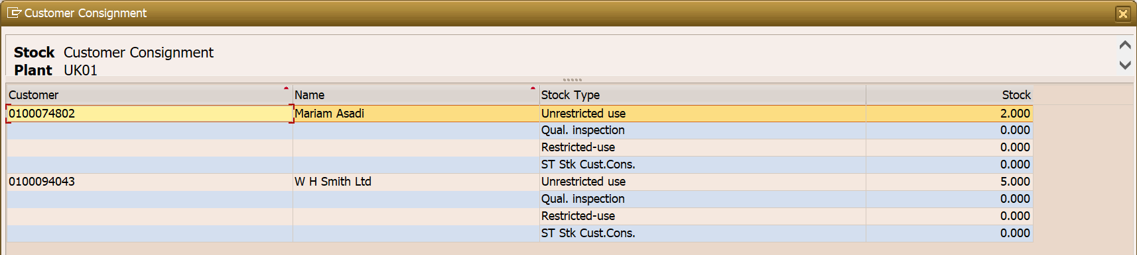

Order creation for ZKB for 5 quantity: 13158  
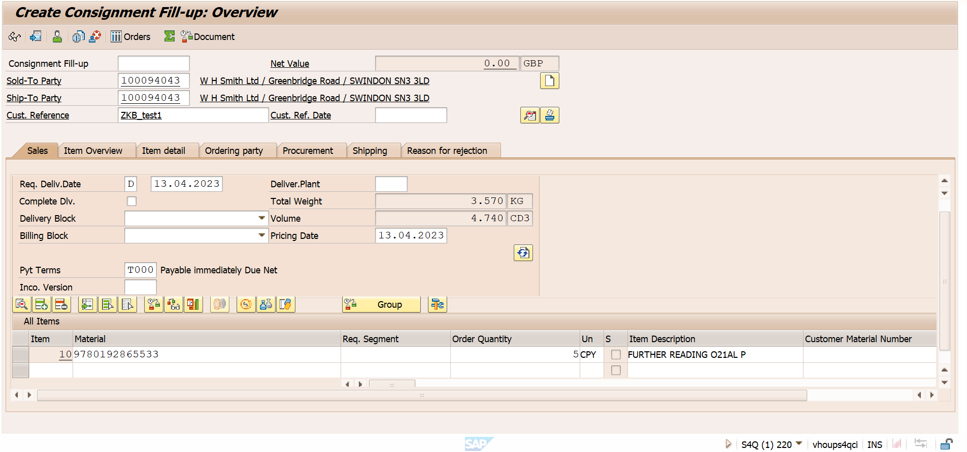

Delivery creation for the order: 13158 🡪 300002493

Picking done:

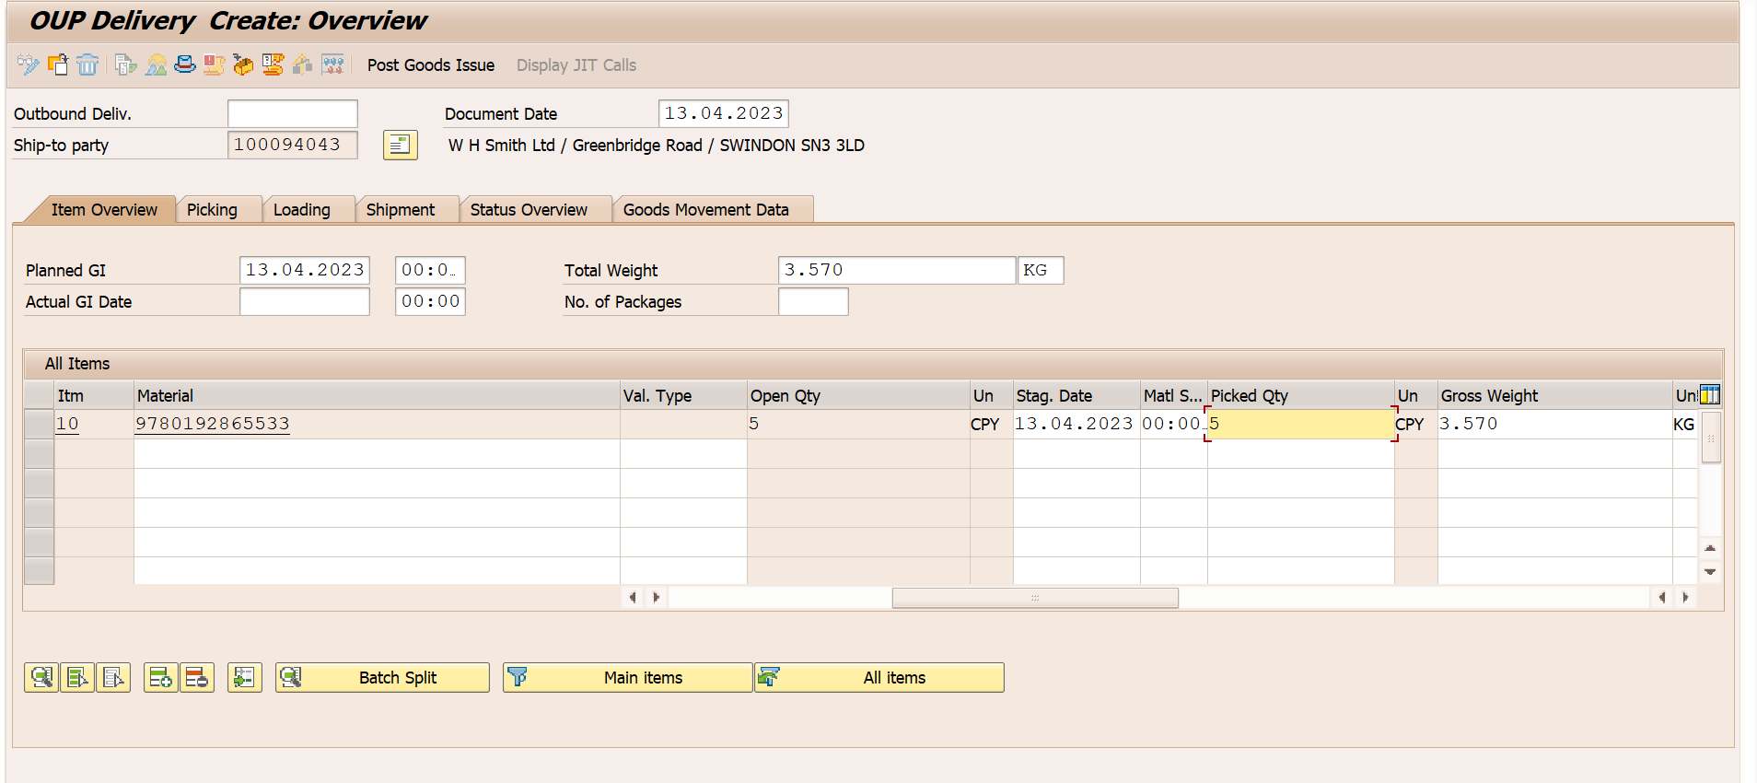

ZKB does not involve Billing. But adds quantity to Special stock

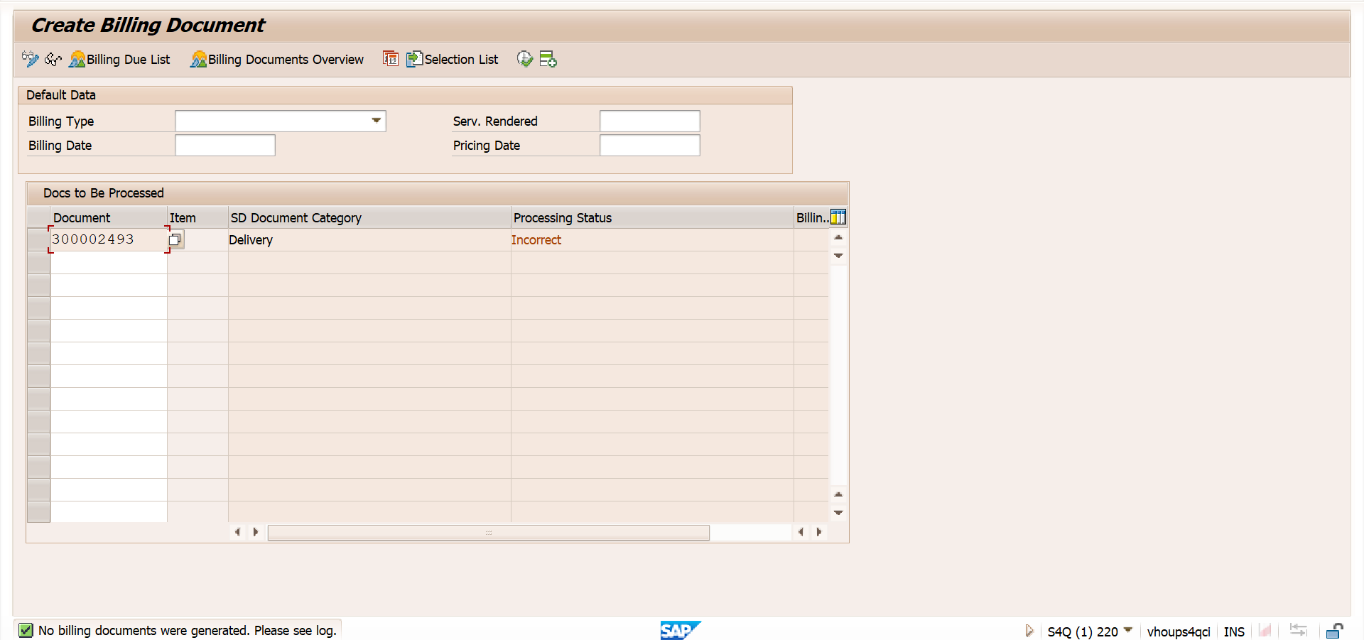

Stock overview post ZKB: Special stock gets updated as 10

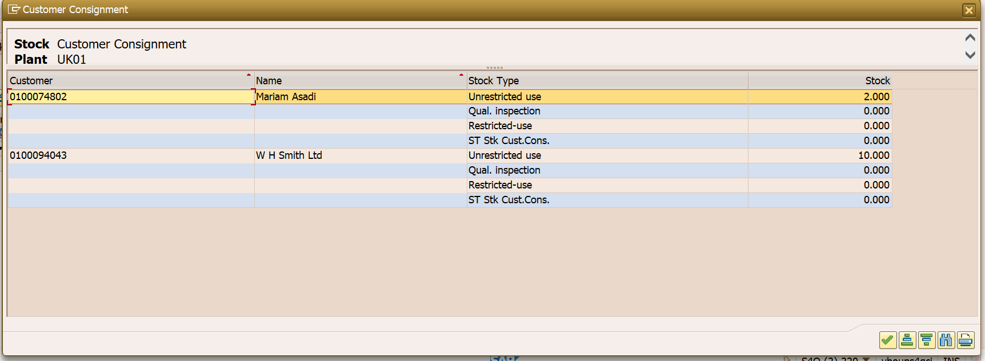

1. ZKE Consignment issue: 13159

Sales document type: ZKE  
Item category: ZKEN  
SLC: C1

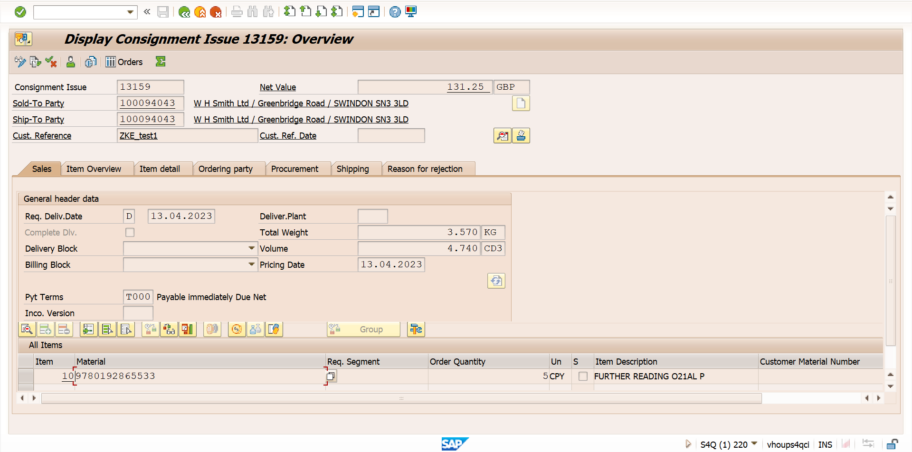

Delivery creation for order(w/o picking): 13159 🡪 300002494

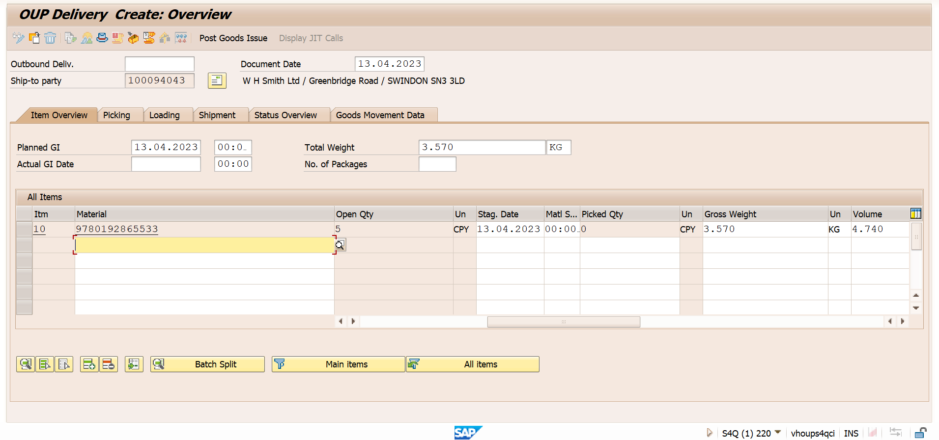

ZKE involves Billing: 13159 🡪 300002494 🡪 500058051

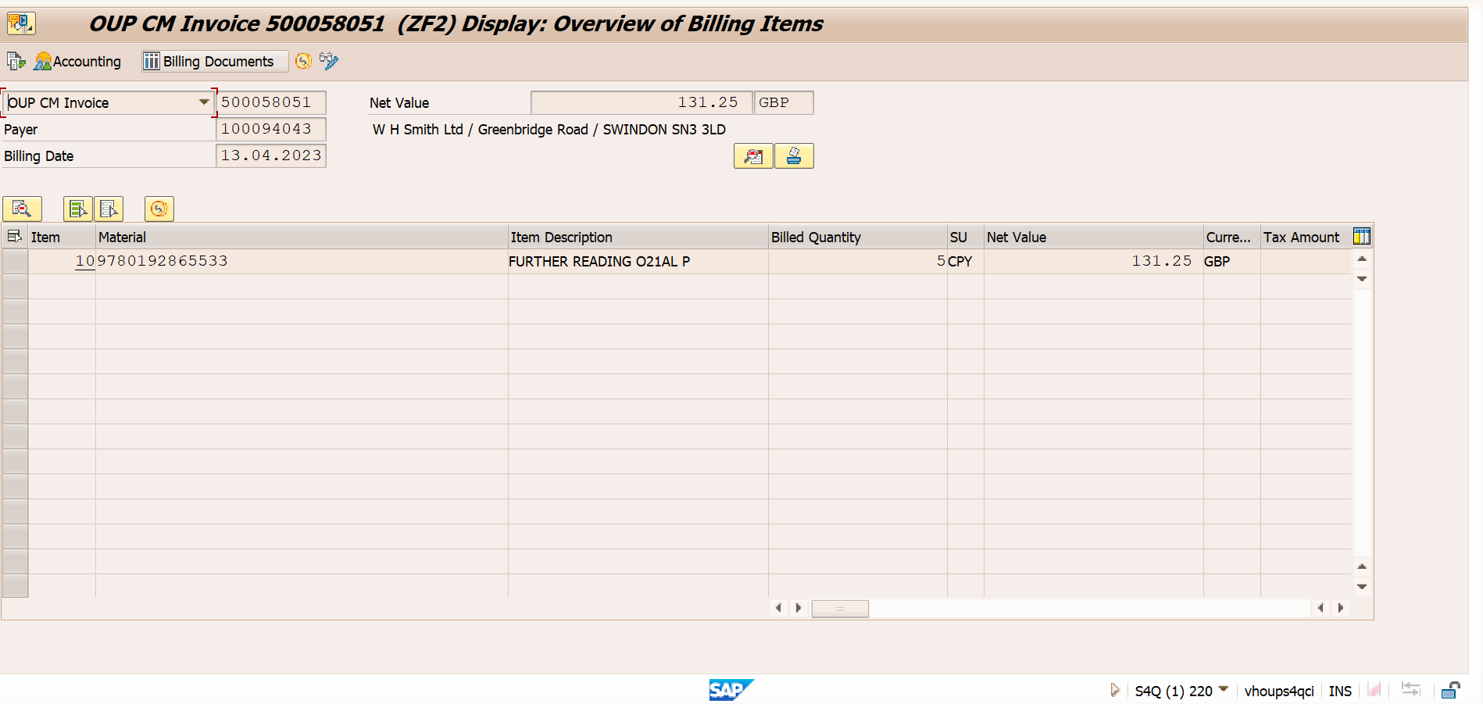

Stock Overview post ZKE: Quantity from Special stock is removed instead of Unrestricted use. Quantity is reduced to 5 from 10

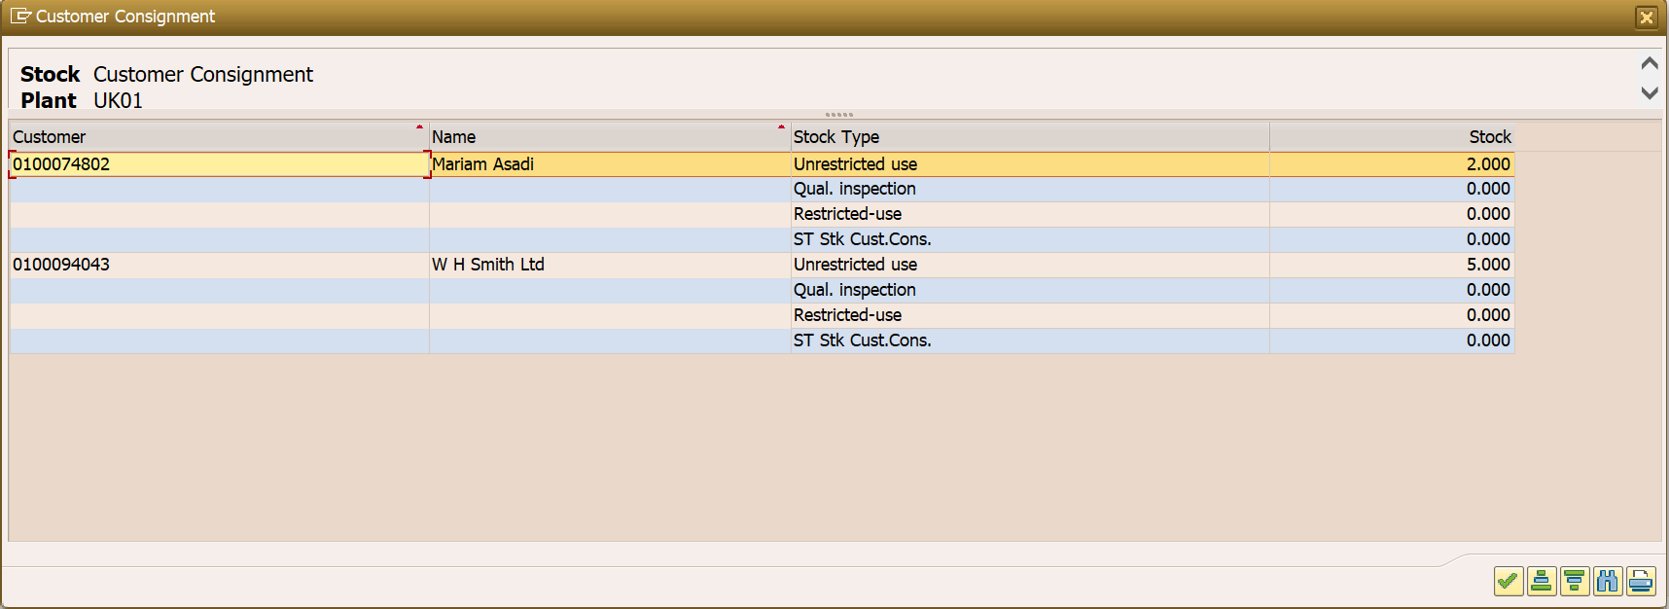

1. ZKR Consignment returns with ZKE invoice as reference: 250001071

Sales document type: ZKR  
Item category: ZKRN  
SLC: D0

Order gets created with Credit Memo, which is removed manually here.

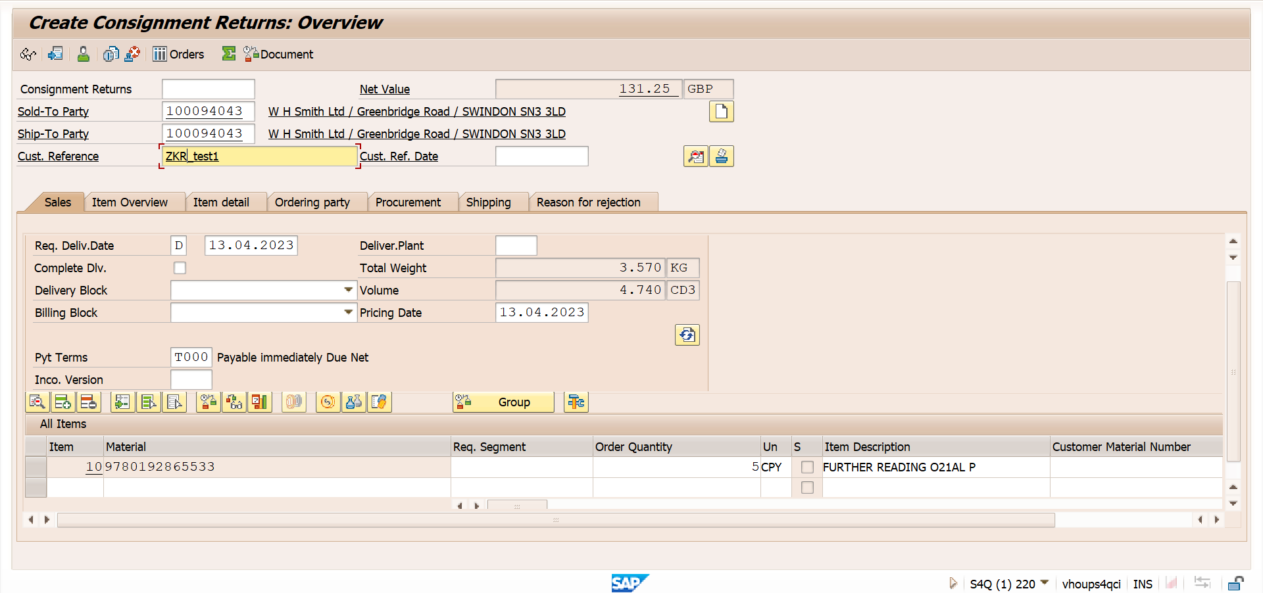

Delivery creation for the same (no picking involved) : 250001071🡪 450000119

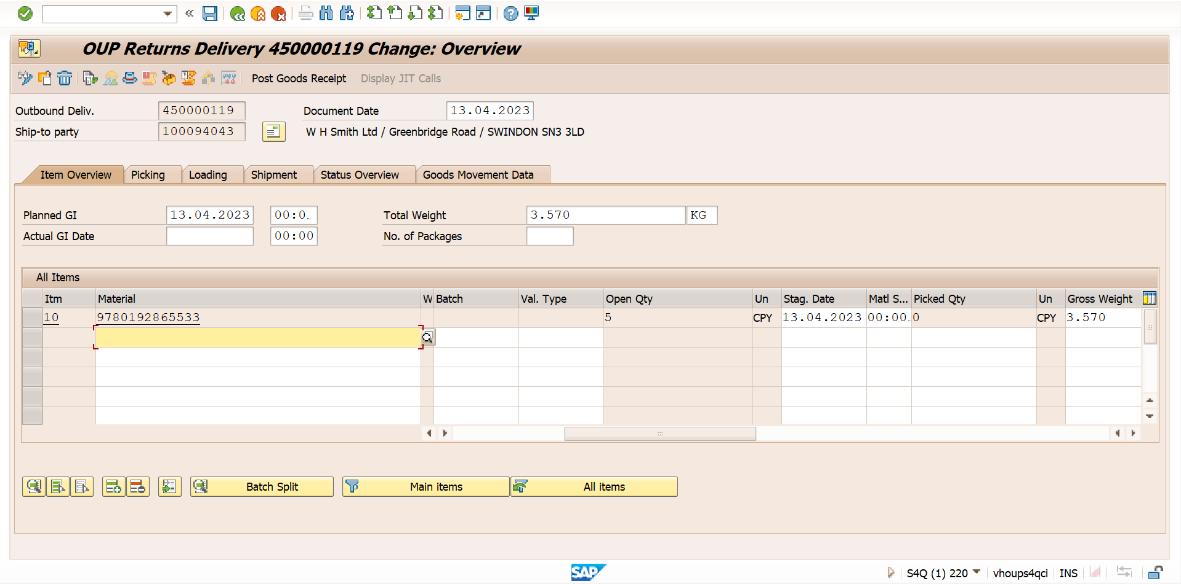

Billing created for the same: 250001071🡪 450000119🡪 700000103

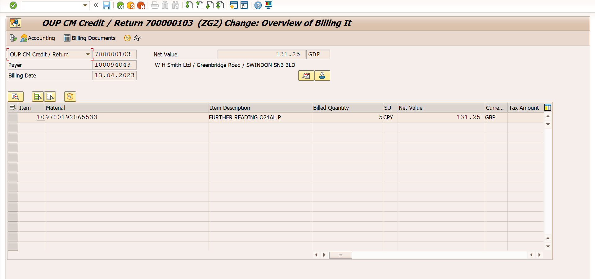

Stock overview after ZKR, Quantity 5 is received in Special stock from Customer.

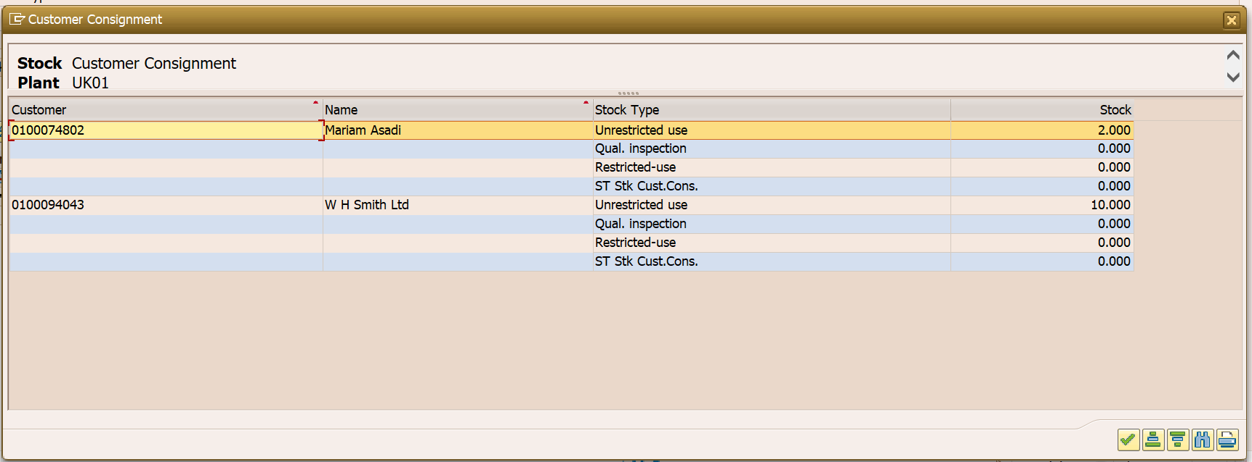

1. ZKA- Pickup order created: 250001073

Sales document type: ZKA  
Item category: ZKAN  
SLC: F1

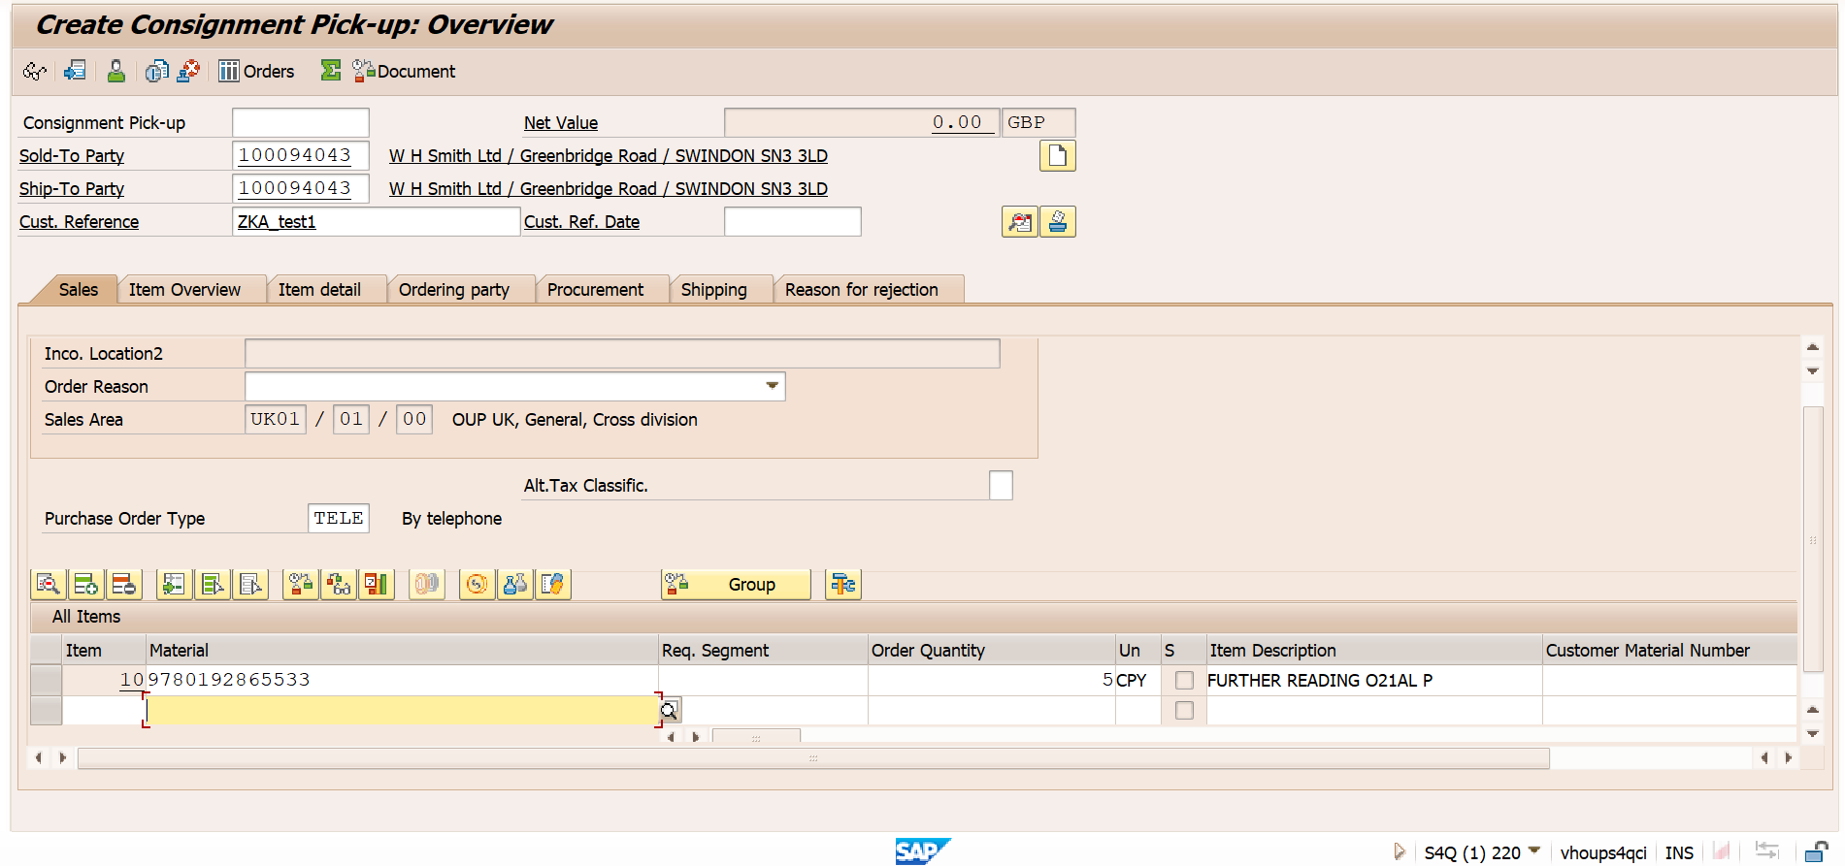

Delivery created for same(no picking involved): 250001073 🡪 450000120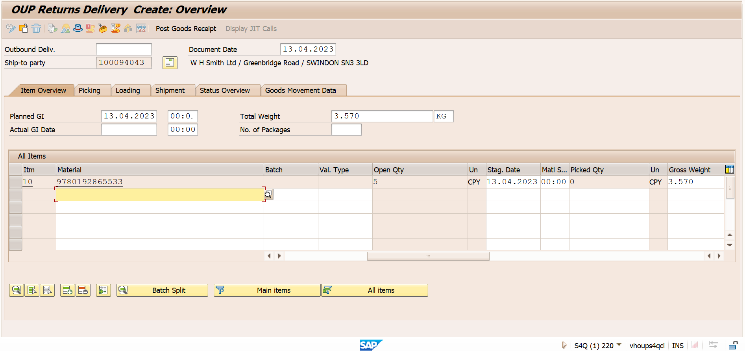

ZKA is not relevant for billing:  
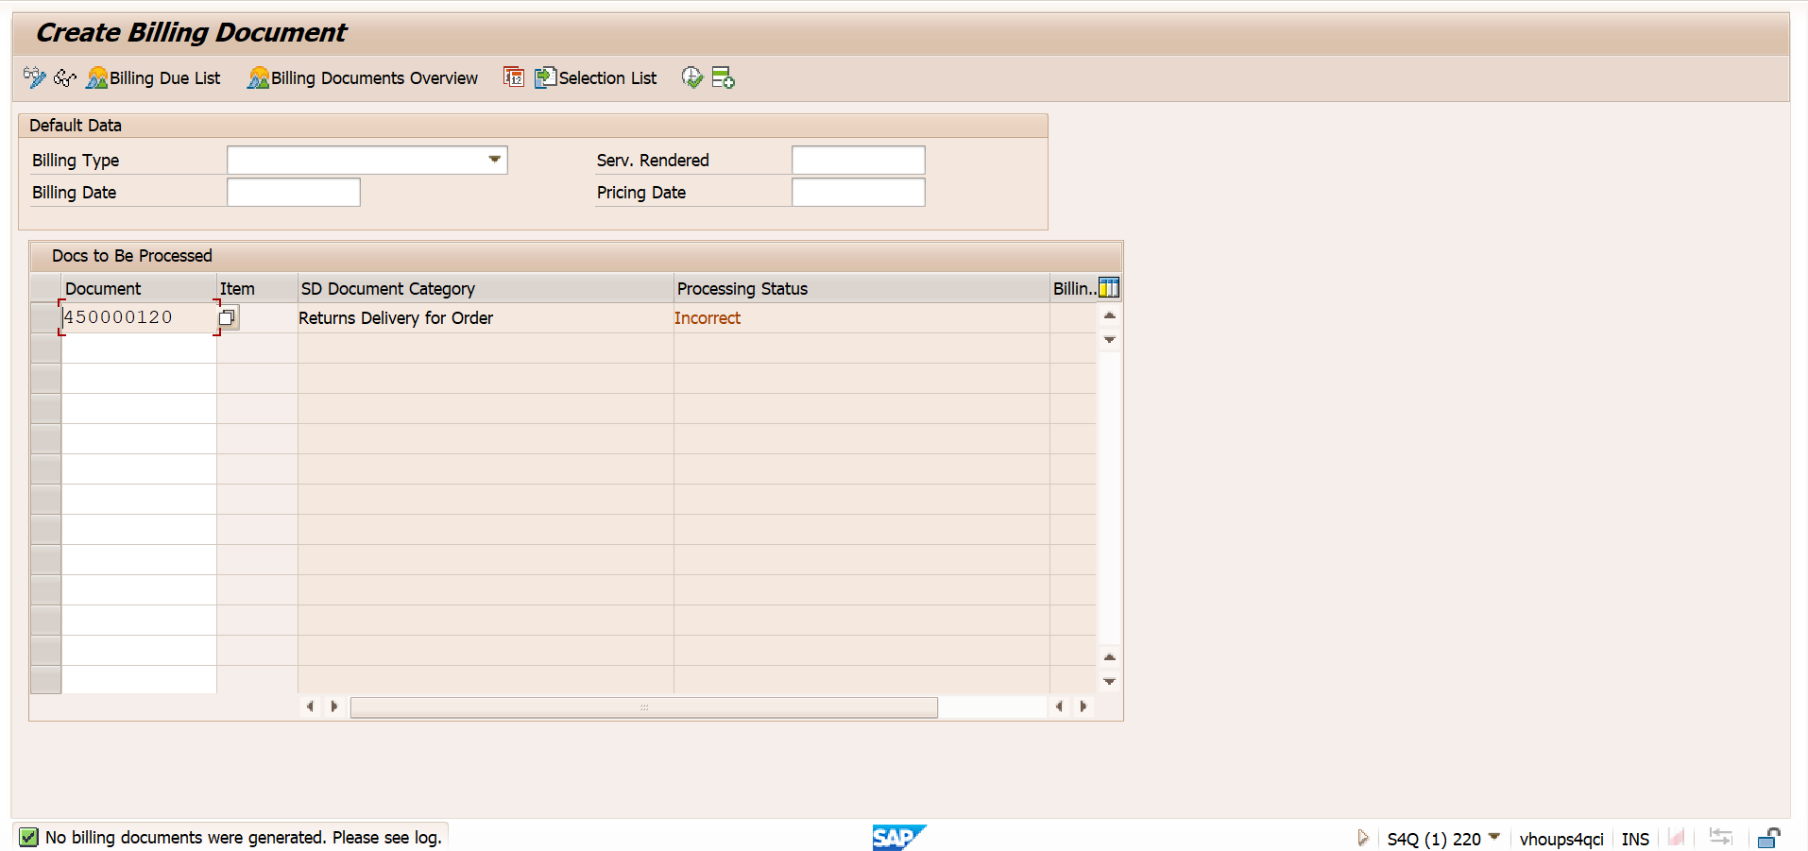

Stock overview post ZKA: Quantity will be removed from Special stock and added to unrestricted stock

